**ModelSim Simulation**

**MdShahid Bin Emdad**

**February 13th, 2022**

**CSC 34200/34300**

**Table of Contents**

Objective _________________________________________________________3

Description of Specifications, and Functionality __________________________3

Explanation ______________________________________________________15

Conclusion _______________________________________________________15

**Objective:**

The objective of this assignment is to create a circuit simulation using Modelsim by following an introductory tutorial of Modelsim and subsequently to create 2:1 multiplexers circuit for 1bit signals only.

# **Description of Specifications, and Functionality:**

The digital system I used in this assignment is ModelSimSetup-20.1.1. In the VHDL editor, I wrote my VHDL code to get the circuit output and then used Modelsim to simulate and run my circuit over time (ns unit).

1. **Introtutorial**

First, we I find the software in my Windows OS.

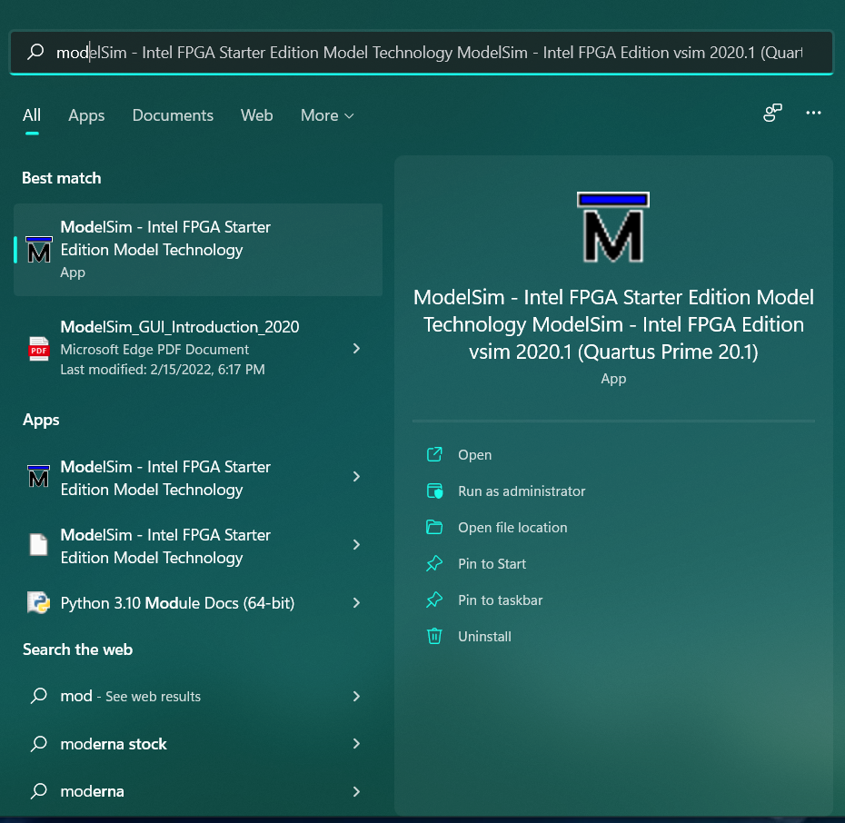

Figure 1: ModelSim Software

In figure 2, I clicked on the ***file***  menu to create a new project.

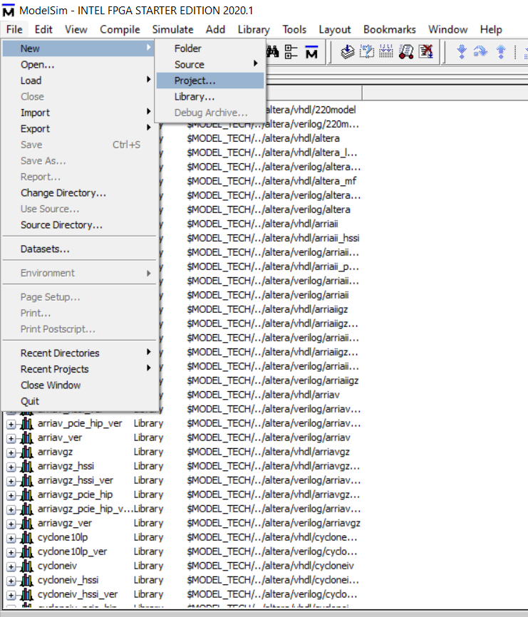

Figure 2: Create new project

In figure 3, I chose my directory path for the project.

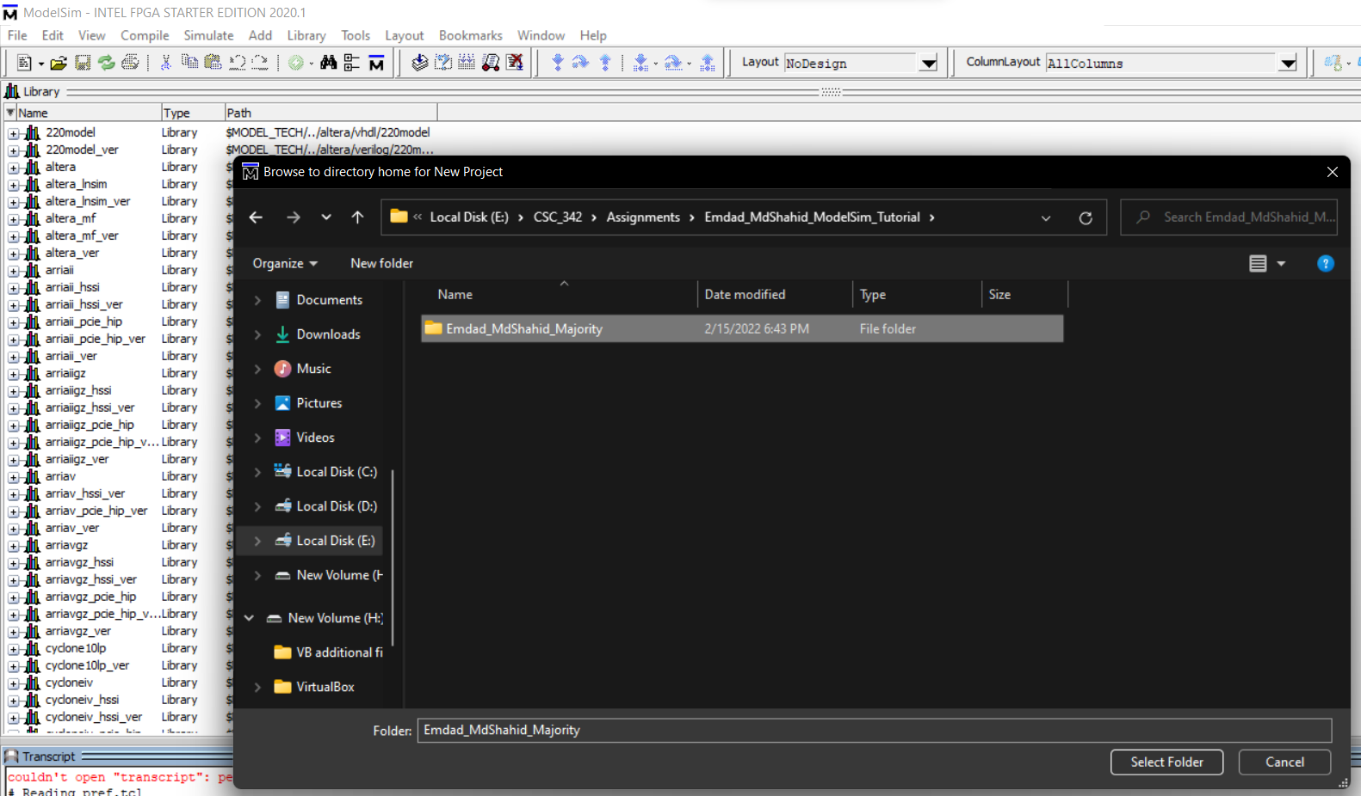

Figure 3: Project Directory

In figure 4, I added my existing VHDL file and uploaded it.

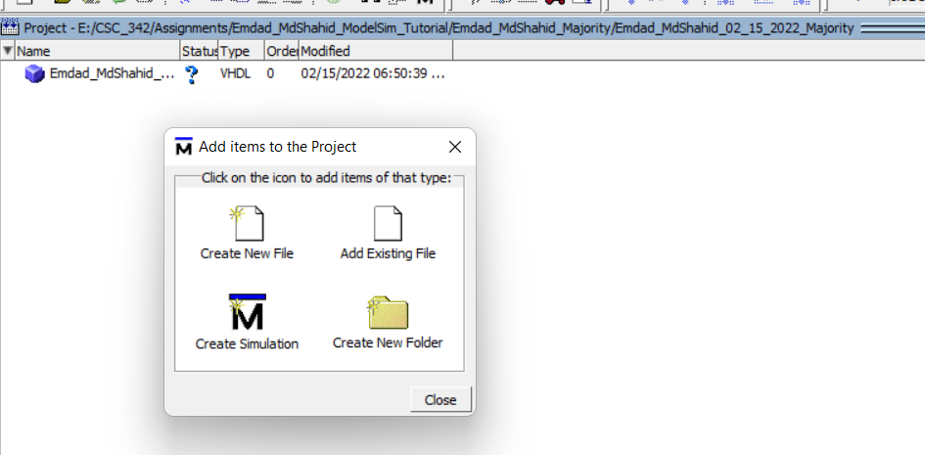

Figure 4: Adding existing vhdl file

In figure 5, I edited my code to see if the code existed fine.

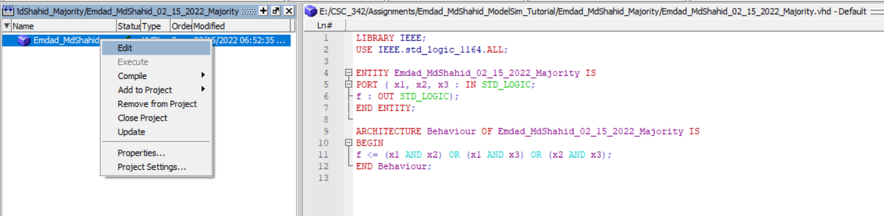

Figure 5: Code checking

In figure 6, I compiled the VHDL file.

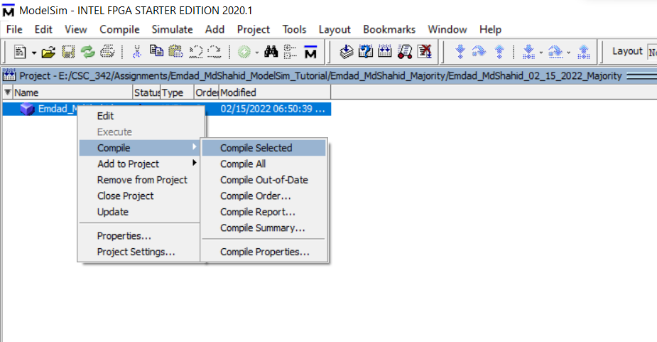

Figure 6: vhdl file compiled

In figure 7, I can see it compiled fine.

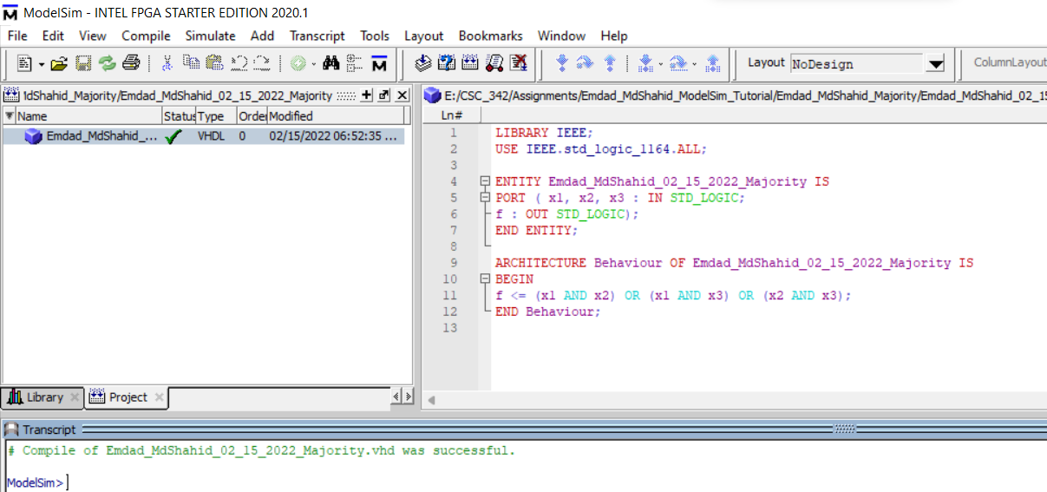

Figure 7: Compiled Successful

In figure 8, I clicked on ***Simulate*** -> ***Start simulation*** to get the wave window.

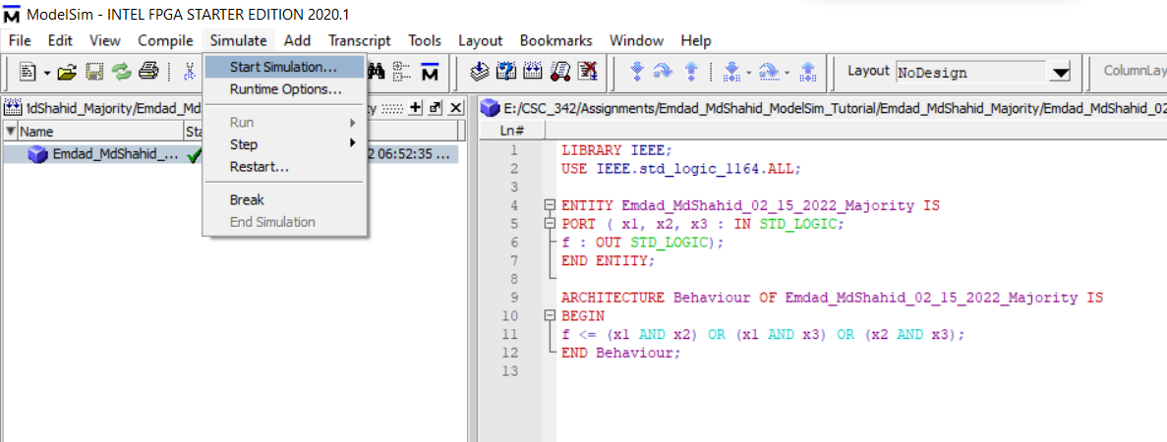

Figure 8: Starting Simulation

In figure 9, I checked on ***work*** to open the entity and select it and click ***OK.***

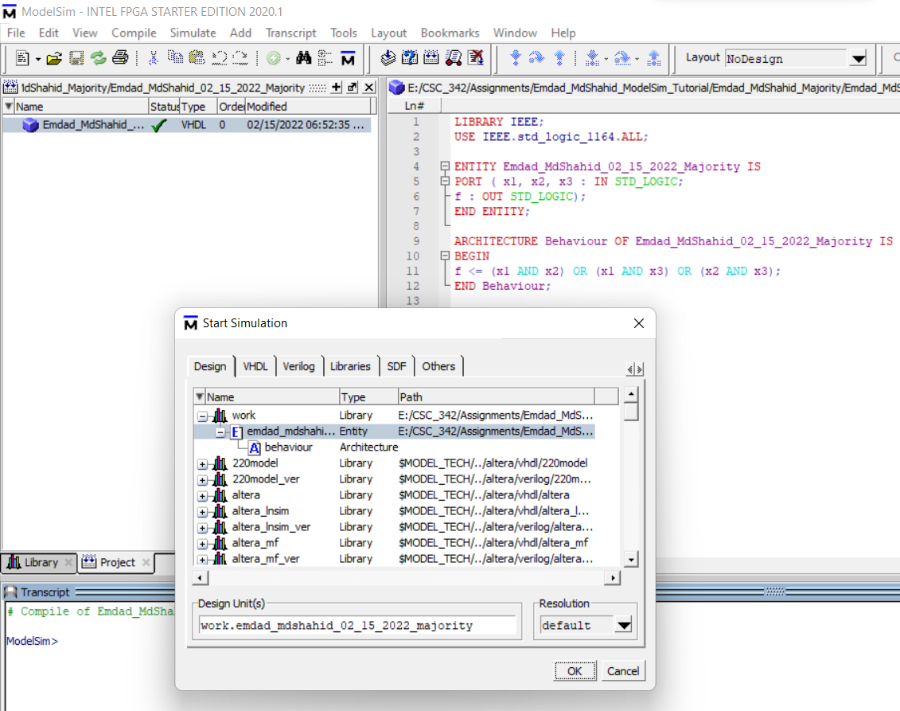

Figure 9: Entity Selection

In figure 10, I started applied wave to x1.

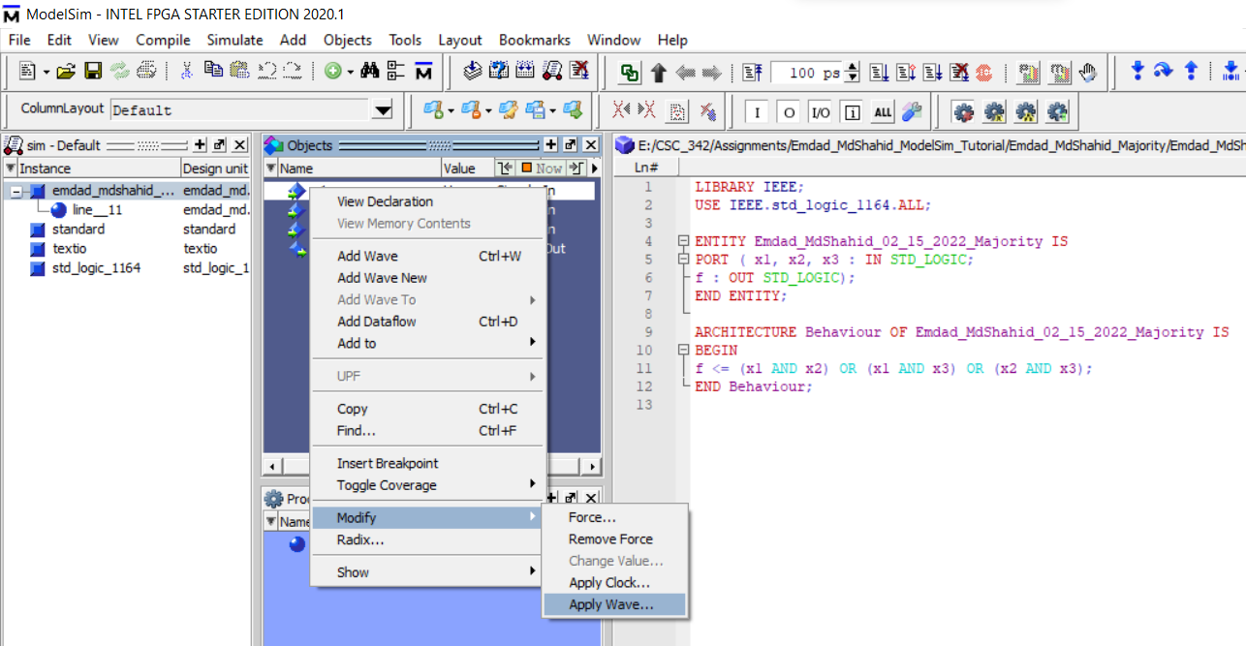

Figure 10: Applying wave to x1

In figure 11, chose the pattern for wave for x1.

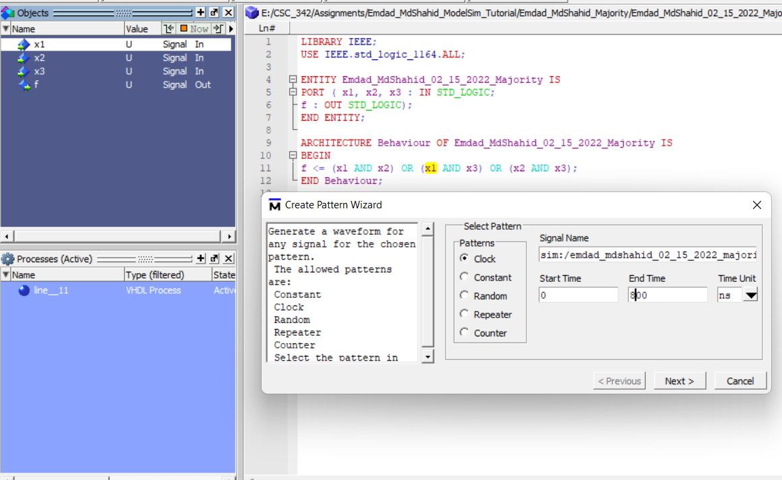

Figure 11: Selecting Pattern wave for x1

In figure 12, I am inputting the clock attributes.

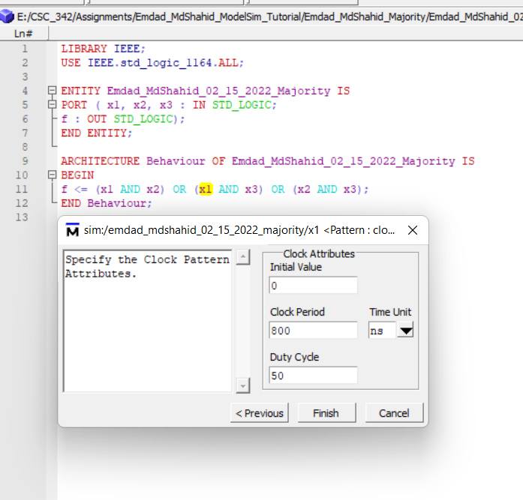

Figure 12: Clock Attributes

In figure 13, I applied wave in the x2 and selecting pattern.

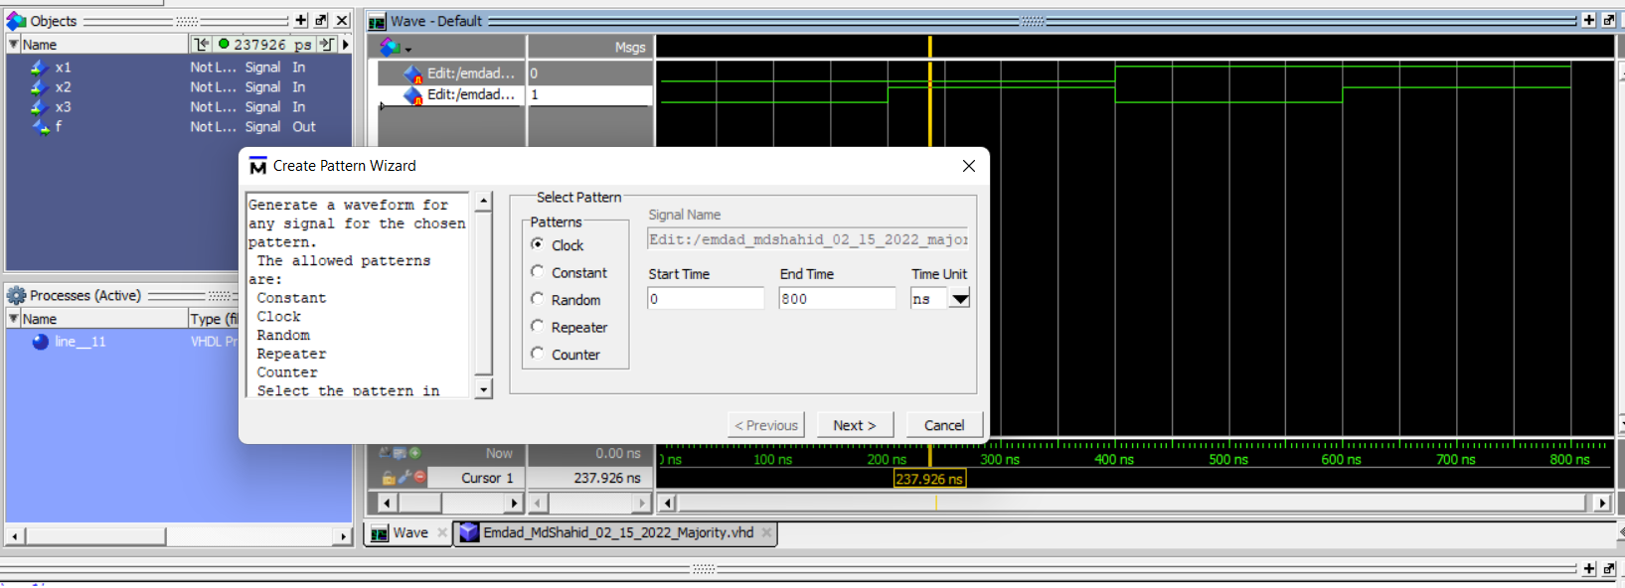

Figure 13: Selecting pattern for x2

In figure 14, I selected the clock attributes for x2.

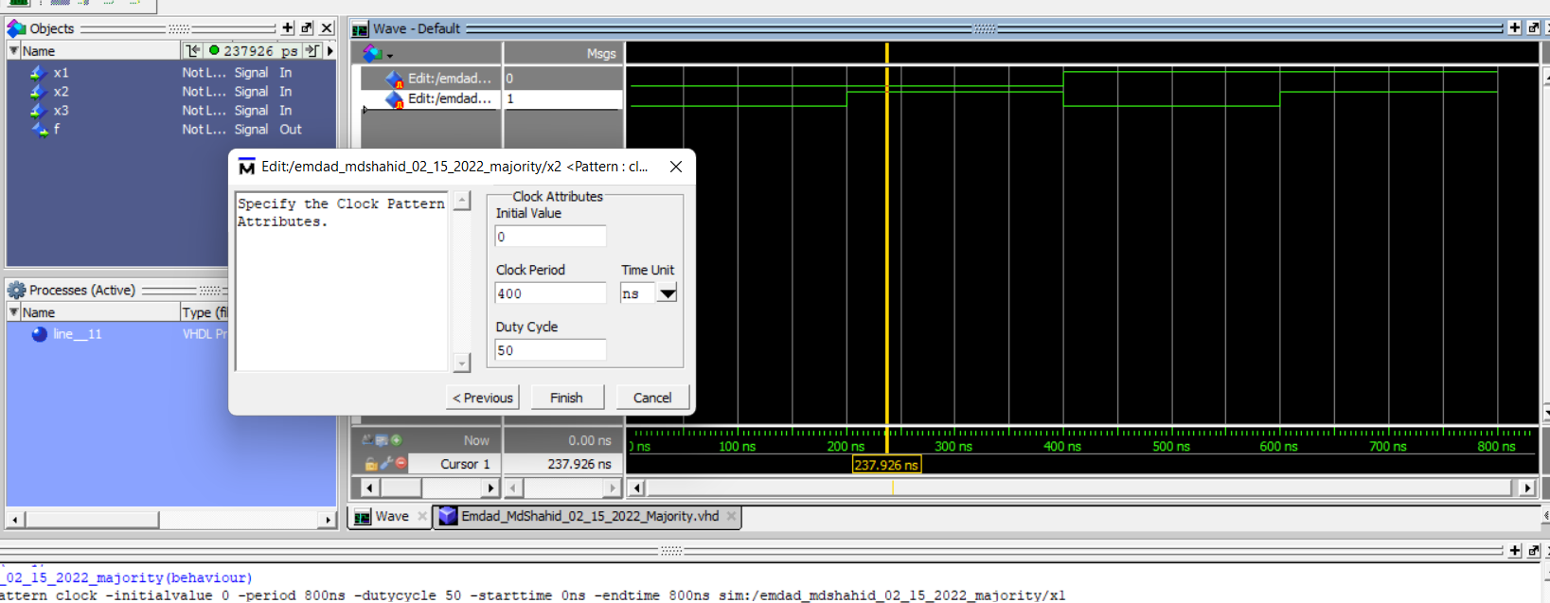

Figure 14: selecting clock attributes for x2

In figure 15, I applied wave in the x3 and selecting pattern.

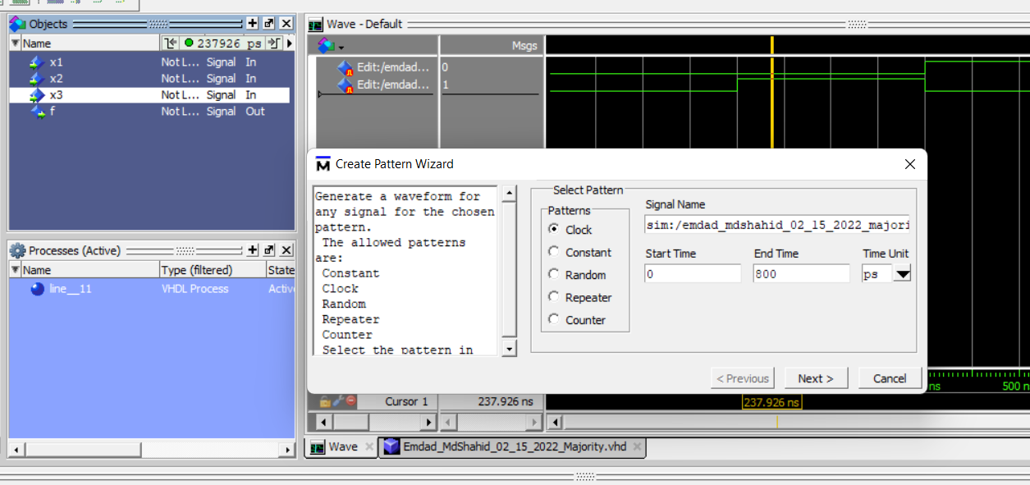

Figure 15: Selecting pattern for x3

In figure 16, I selected the clock attributes for x3.

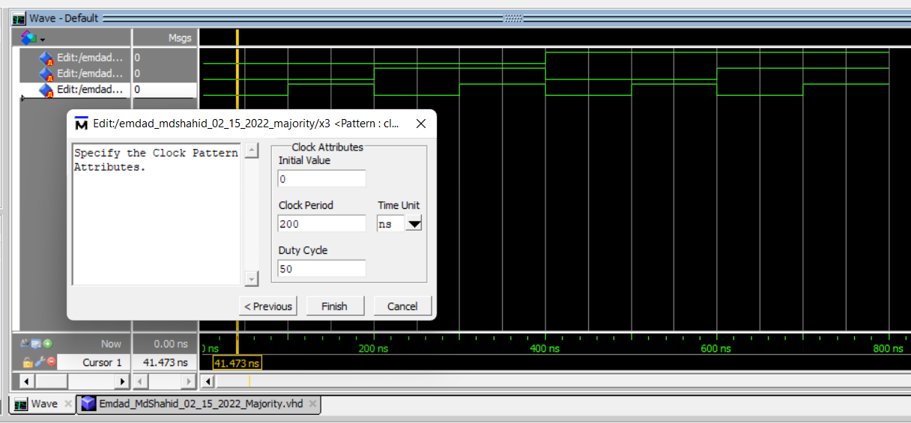

Figure 16: selecting clock attributes for x3

In figure 17, I selected signals to get the output of the circuit.

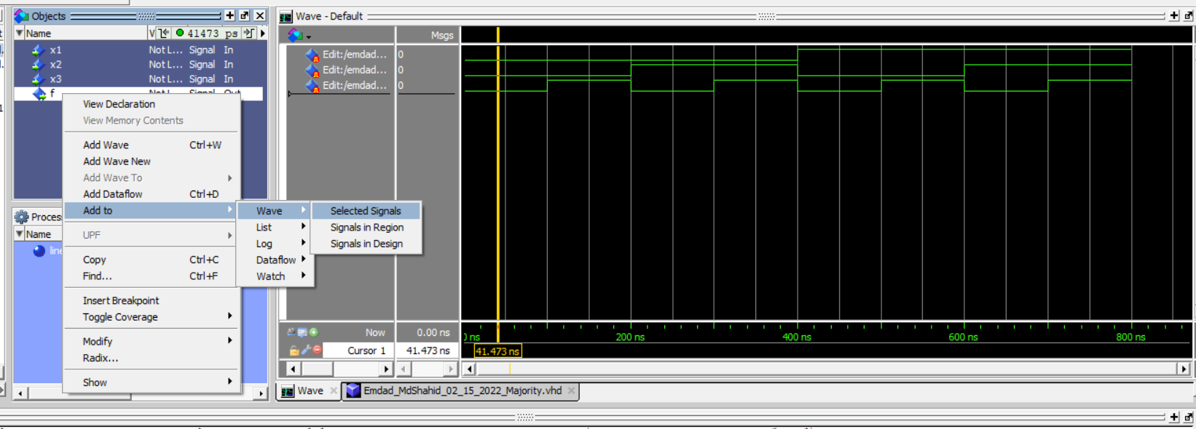

In figure 18, we can see the total wave output of the circuit.

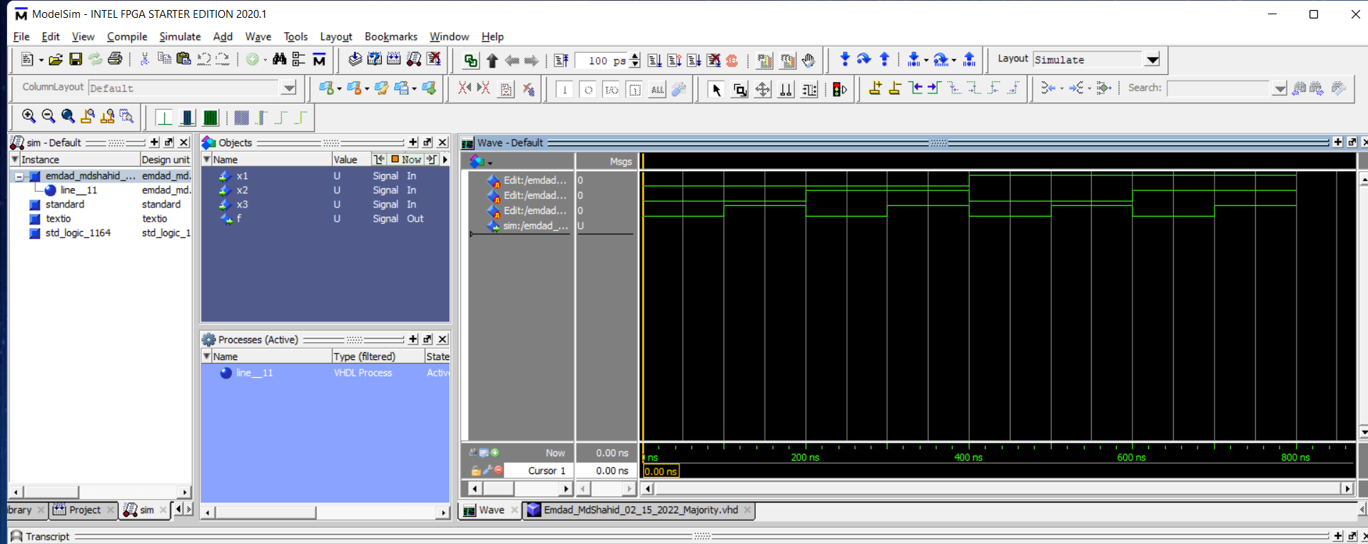

Figure 17: Waveforms Output

In figure 18, I saved my format for this simulation.

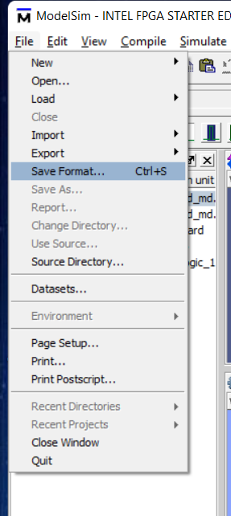

Figure 18: Saved the simulation format

In figure 19, we can see simulation output by running the simulation.

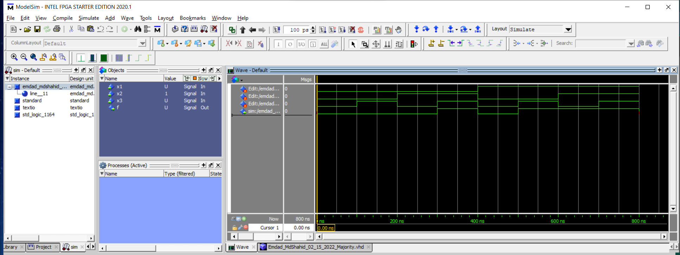

Figure 19: Ran simulation

In figure 20, I changed the initial value of x1 to 1 which changed the simulation waveform output totally.

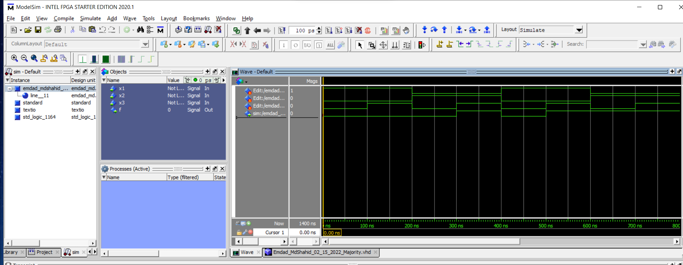

Figure 20: Different waveform based on initial value changed

1. **2:1 mux 1-bit**

In figure 21, I added the existed the file in the new project and then compiled it. As we can, the VHDL compiled successfully.

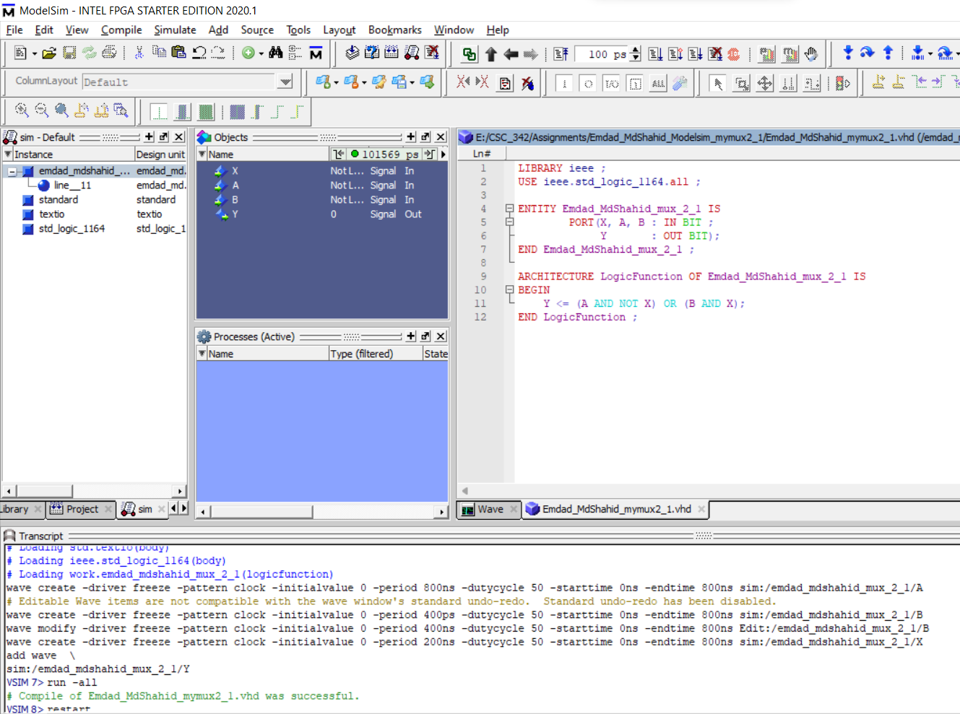

Figure 21: vhdl file compiled

In figure 22, we can see the final output of all the waveforms.

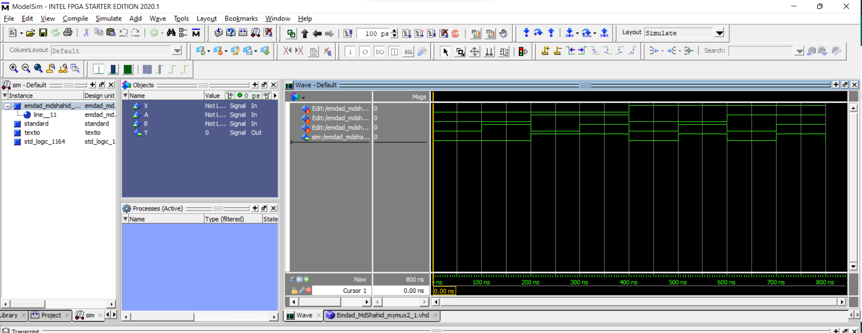

Figure 22: mymux2_1 waveform output

**Explanation:**

For part A, I totally followed the instructor tutorial. I looked at the waveform output on Page 15 and from there I checked if I did it in the right way. For mymux2_1 1bit signals only, I focused on the truth table. Each input from the truth table is divided by 100ns which in total 800ns for the timeline. Then I set the wave and clock pattern and attributes in that way. Then I ran the simulation to see if my output wave matched with the truth table and it did. Hence, the waveforms are right.

**Conclusion:**

This assignment was helpful to learn modelism and simualtion in Modelism software. It was a thorough and brief tutorial to learn the software. The operations and condition logics were helpful to learn easily. The truth table helped me to get the circuit waveform quicker. I relearned and reviewed the concept again and which will help me in the course further.